The HINDU COMMUNITY CENTER 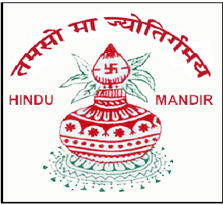
GARFIELD AND KEARNY, NEW JERSEY
For Holy SHRAVAN MONTH

Organizes

YOGA WORKSHOP and SPIRITUAL DISCOURSES
TO BE CONDUCTED BY
H.H. Swami Shri Adhyatmanandji Maharaj
(President, Sivanand Ashram, Ahemedabad, India)
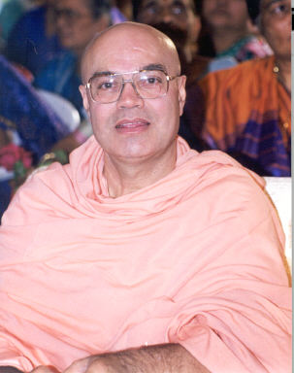
One of the greatest yoga teachers of this era and the most sought after orators, H. H. Shri Swami Adhyatmanandaji Maharaj (Sivananda Ashram, Ahemedabad, India) has conducted more than 700 yoga classes in India and abroad for armies, universities and private sector companies. His writings and lectures are spontaneous outpouring of divine wisdom. Making the most esoteric subjects of spirituality simple through a perfect blend of humor, melodious singing and down to earth practical approach, Swamiji has touched and inspired millions of listeners in the last thirty five years of his monastic life. A great motivator for the modern youth, he has made an enormous difference in their lives by inspiring them to attain success and learn true values. His weekly articles in Gujarat Times take you through the journey of the internal mechanics of human body and how yoga improves their functioning at the optimum level.
Tuesday, July 31 2012 To Friday, August 3 2012
Timings | Morning Session | Evening Session
Day / Date | 7:30 AM to 9:30 AM | 5:30 PM to 7:30 PM
Tuesday - 07/31/12 | - | DWADASH JYOTIRLING MAHATMAYA -  Spiritual Discourse  followed by Aarti and Prasad
Wednesday - 08/01/12 | Yoga Session
Thursday - 08/02/12 | Yoga Session
Friday - 08/03/12 | Yoga Session | -
Saturday - 08/10/12 | - | Shree Krishna Janamashtami Celebration 7:30 PM onwards
……………Please Note…………...
Yoga Workshop requires registration: Adult and Children 10 years and up. Suggested Donation - $31.00 for three days, will include light breakfast
Spiritual Discourses are open to all, no registration required.
10:30 AM to 2:30 PM and 8 PM to 9 PM is open for Swamiji's Visit / Bhiksha to devotee’s houses. To Schedule visit timings contact Tejalben Shah
Event Location: H.C.C., 156 Schuyler Ave., Kearny, NJ 07032
Directions: http://hindumandirnj.org/

Questions? Contacts

Sureshbhai Patel: 201-797-9383; Nitinbhai Desai: 973-942-1152; Amit and Tejal Shah: 973-253-8491; Yogesh Mehta: 973-365-2106;

Temple Office: AmbaJi Mandir - 201-997-5556, Vaikunth Dham - (973) 546-7331

