

YOGA WORKSHOP
TO BE CONDUCTED BY
H.H. Swami Shri Adhyatmanandji Maharaj
(President, Sivanand Ashram, Ahemedabad, India)

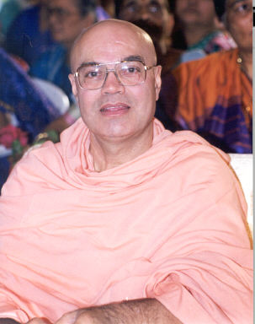

One the greatest yoga teachers of this era and the most sought after orators, H. H. Shri Swami Adhyatmanandaji Maharaj (Sivananda Ashram, Ahemedabad, INDIA) has conducted more than 600 yoga classes in India and abroad for armies, universities and private sector companies. His writings and lectures are a spontaneous outpouring of divine wisdom. Making the most esoteric subjects of spirituality simple through a perfect blend of humor, melodious singing and down to earth practical approach, Swamiji has touched and inspired millions of listeners in the last thirty-five years of his monastic life. A great motivator for the modern youth, he has made an enormous difference in their lives by inspiring them to attain success and learn true values. His weekly articles in Gujarat Times take you through the journey of the internal mechanics of human body and how yoga improves their functioning at the optimum level.

Saturday, August 11, 2012
9am – 11am
Prem-Kunj, 3 Masar Rd, Boonton, NJ 07005

Contact
Pappu Sodhani (973) 334-5917

